**Assignment – 2 CSC-575**

Question 3

Part 1)

The author is using 6 different methods for improving the F0 estimation accuracy of a standard autocorrelation-based method.

Step 1 10.0 - The autocorrelation method

Step 2 1.95 - Difference function

Step 3 1.69 - Cumulative mean normalized difference function

Step 4 0.78 - Absolute threshold

Step 5 0.77 - Parabolic interpolation

Step 6 0.50 - Best local estimate

As per the above data given in the paper we can make out that the Step 2 has decreased the Gross Error Percentage from 10% to 1.95%, and that is a remarkable drop in the error percentage.

Reason – The implemented ACF – Autocorrelation function in the equation is sensitive to amplitude changes.

Part 2)

We have a lot of questions on autocorrelation and this paper also has its relevance so I will talk about the figure that relates to this concept.

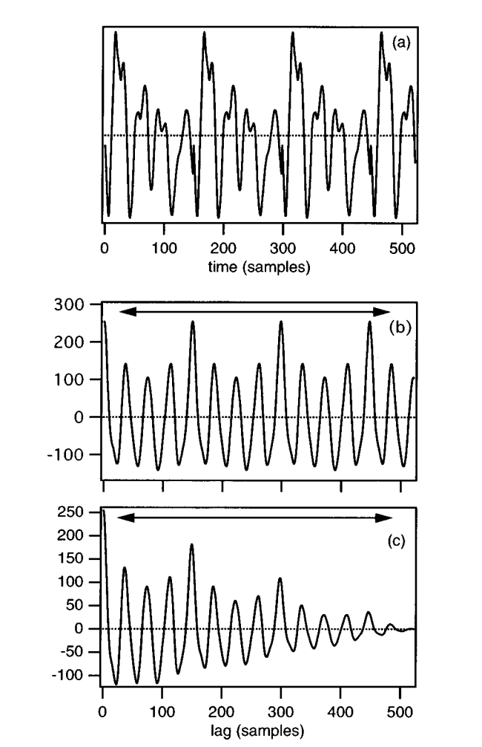

Autocorrelation, also known as serial correlation, is the correlation of a signal with a delayed copy of itself as a function of delay. Informally, it is the similarity between observations as a function of the time lag between them. (wiki)

Figure 1 represents an example of a speech waveform; the second image is obtained after applying the autocorrelation function using the equation –

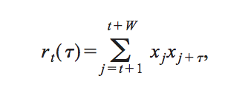

In the third image, also we calculated the same but the envelope of this function is tapered to zero because of the smaller number of terms in the summation at larger t. The horizontal arrows symbolize the search range for the period.

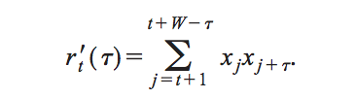

Part 3)

Interpolation is used in the Step 5 for the methods to improve the F0 estimation accuracy of a standard autocorrelation-based method.

Reason – All the previous methods were based on the fact that the period was the multiple of the sampling period. Also the calculations may be incorrect by up to half the sampling period.

A solution to this problem is parabolic interpolation. Each local minimum of d(t ) and its immediate neighbors is fit by a parabola, and the ordinate of the interpolated minimum is used in the dip-selection process.

Part4)

The sections after the step 2 were real hard to understand because it involved a lot of equation manipulation and graph/wave analysis. I am not satisfied with the author’s explanation of this method at the later stages. When he talks about the Absolute threshold, I do not understand the subharmonic/ octave error.

After reading an understanding: -

1. Subharmonic error/Octave Error - improperly because not necessarily in a power of 2 ratio with the correct value.